Avocado Sales Forecasting and Optimal Supplier Decision-Making Across Key Markets
By: Deep Sharma

Avocado consumption in the United States has grown steadily over the years, creating a dynamic market where demand can change from week to week and vary across regions. For suppliers and distributors, this creates a logistical challenge: they must make sure stores have the optimal amount of product at the right time while avoiding overstocking and unnecessary costs. Successfully managing these decisions requires more than just looking at past sales, it also requires forecasting future demand and planning supply strategies based on those predictions.

Historical sales and price data can help meet this challenge by revealing patterns in consumer behavior. Weekly sales records highlight trends, seasonal fluctuations, and regional differences. Some markets maintain steady demand throughout the year, while others experience peaks or slow periods at certain times. Understanding these patterns is essential not only for anticipating future sales but also for deciding which supply strategies are likely to be most effective. This includes evaluating options such as sourcing domestically, importing, or using a combination of both approaches.
This project takes a closer look at forecasting and supply planning by combining predictive and prescriptive insights from historical sales and price data. The predictive analysis estimates weekly avocado sales for the next year in three selected markets, highlighting trends, and regional demand differences. These forecasts provide suppliers with a clearer understanding of the quantity of product required each week under typical conditions. The prescriptive analysis uses this information to explore different sourcing strategies, including domestic, imported, and a combination of both approaches, to highlight which option could be most effective. Together, the analyses provide a practical example of how data-driven insights can support thoughtful planning and decision-making.

Data Overview
To support accurate forecasting and informed strategic recommendations, we relied on a high-quality dataset. Collected by the Hass Avocado Board and publicly available on Kaggle, it contains 53,415 weekly records of avocado sales and prices across the United States from 2015 to 2023. Each record includes the week-ending date, average selling price, total volume sold in pounds, and sales broken down by avocado size using the Hass Avocado PLU codes: small/medium (4046), large (4225), and extra-large (4770). The dataset also tracks pre-packaged bags, including total bags sold and counts for each bag size, as well as specifies the avocado type and the region where the sales occurred. This level of detail makes it possible to examine sales trends, pricing patterns, and consumer preferences across different regions and product categories.
Initial Findings
Before preparing the dataset for forecasting, we took time to explore the data and understand the broader patterns in sales volume, pricing, and regional behavior. One of the first comparisons involved looking at conventional and organic avocados. The difference between the two was clear, as shown in the barplot below. Across all regions and years, conventional avocados made up the vast majority of total sales, while organic sales were much smaller. Since conventional products represented the most consistent and substantial share of the market, we focused the remainder of the analysis on this product type.
We also reviewed which regions contributed the most to overall avocado sales. Large metropolitan areas such as Los Angeles, New York, and Dallas-Fort Worth consistently reported some of the highest volumes in the dataset. Their strong and steady demand made them practical choices for forecasting and for examining supply strategies in later stages of the project.
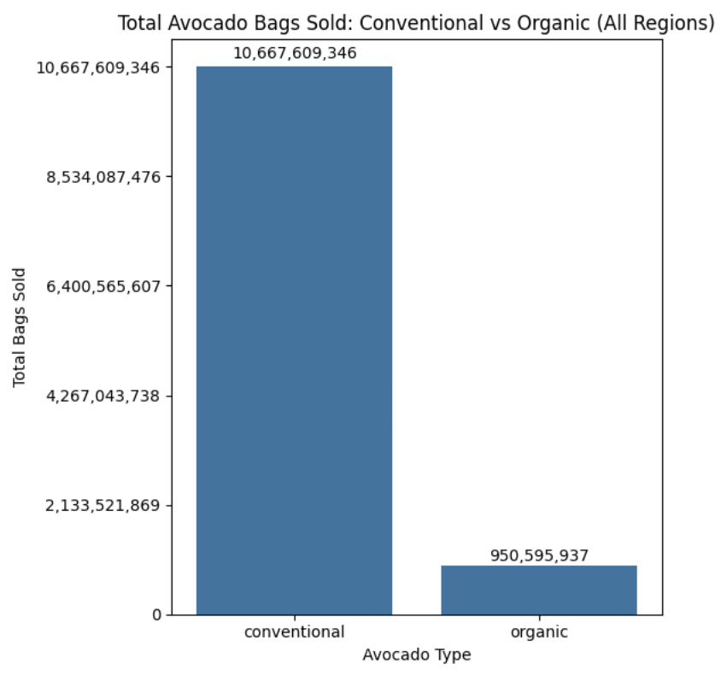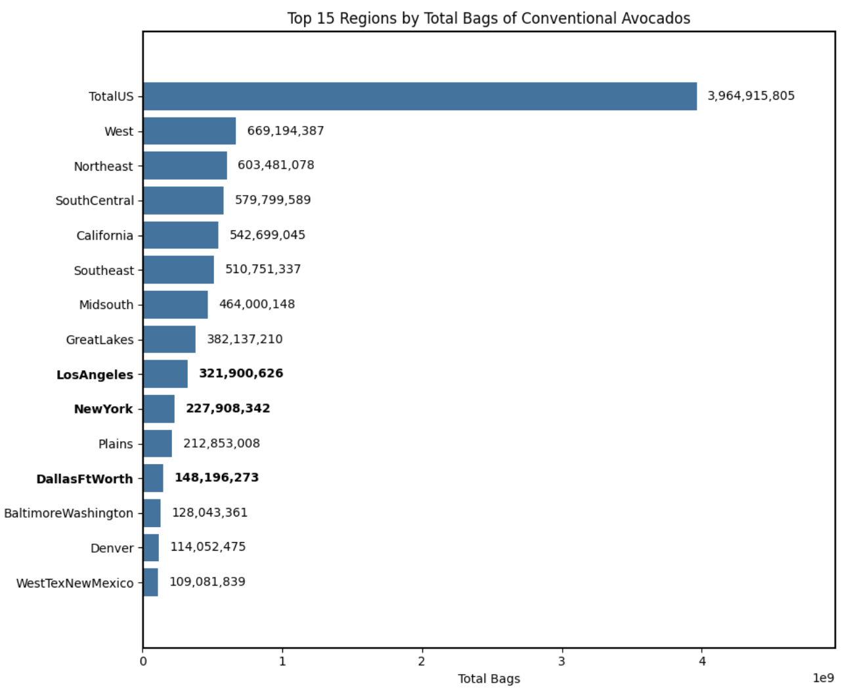
Data Preprocessing
To prepare the raw dataset for modeling, we followed a series of steps to ensure the data was accurate, consistent, and ready for forecasting. We began by creating a copy of the original dataset to preserve its integrity and then checked for duplicated records. None were found, which allowed us to move forward confidently with the cleaned version.
As we continued reviewing the data, we noticed that the bag size columns contained roughly twelve thousand missing values. After examining these patterns more closely, it became clear that the missing values were intentional rather than errors. When one type of bag was sold in a given week, the remaining bag size columns often appeared as null simply because no units of those sizes were purchased. Since the nulls represented zero sales rather than unknown information, we replaced all missing values in the bag-related columns with zero.
With the missing values addressed, we verified that each column had the correct data type. We then converted the Date column into a datetime format to support time-based analysis. This allowed us to create three new features: Month, Year, and Week. The Month feature helped reveal seasonal purchasing patterns, the Year feature supported comparisons across multiple years, and the Week feature provided a consistent index for analyzing weekly fluctuations in demand.
Predictive Analysis
Once the dataset was fully prepared and enriched with the new time-based features, we moved forward with developing the forecasting model. Since our goal was to predict weekly avocado demand, the first step was to resample the data to a weekly frequency. This ensured that the historical records were aligned consistently and allowed us to capture recurring seasonal patterns that tend to appear throughout the year.
We then focused on the three metropolitan regions identified during the initial findings: Los Angeles, New York, and Dallas-Fort Worth. These regions were chosen because they provide complete, high-quality historical data and represent major demand centers. For each region, we divided the data into a 70-30 train-test split, using 70 percent of the weekly observations to train the model and the remaining 30 percent to evaluate its performance. This approach allowed the model to learn from past trends while being tested on data it had not seen before.
To generate the forecasts, we applied an Autoregressive (AR) model, which predicts future values based on past observations. This approach works well for time-series data where historical trends strongly influence future behavior. To ensure the model was reliable and generalizable, we performed cross-validation, evaluating performance across multiple subsets of the data. This step helped confirm that the model was consistent and not overly tailored to the training set.
The results showed that the model predicts future demand with solid accuracy, with percentage errors ranging from about 7 percent to 13 percent across the three regions. Dallas-Fort Worth was the most predictable region, likely due to its smoother and more stable demand patterns. Los Angeles showed slightly more variation, while New York had the highest forecast error because of more frequent fluctuations and occasional spikes in weekly sales.
By combining weekly resampling, a structured train-test split, cross-validation, and the AR modeling approach, we produced reliable 52-week demand forecasts for each region, as seen in the graphs below. The forecasts indicate that weekly sales for the three markets are expected to remain around 2.9 million units per week, which is roughly 420,000 units per day. These results provide a clear view of expected trends and a solid foundation for supporting effective decision-making in avocado retail planning.
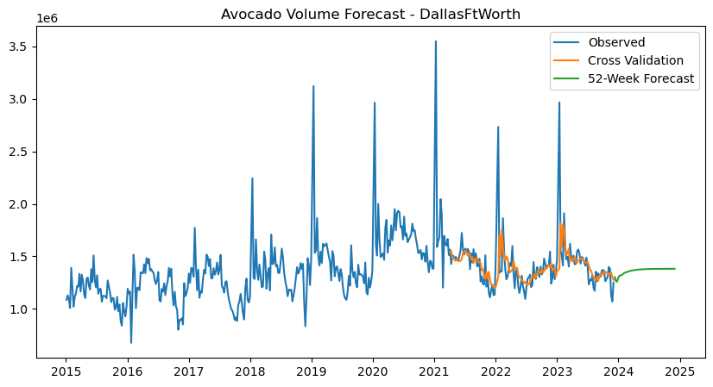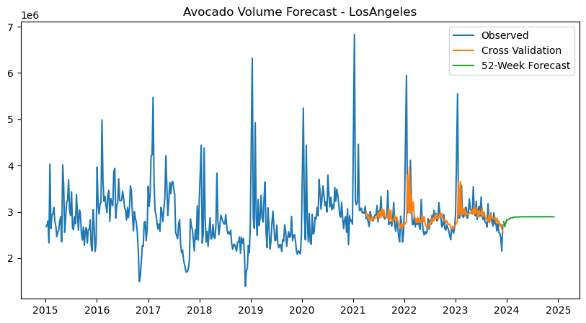
Prescriptive Analysis
For the prescriptive analytics portion of our project, we developed an optimization model designed from the perspective of a supplier and distributor responsible for allocating avocado shipments across different markets. The objective was to minimize total shipping costs while determining the most efficient distribution of the three avocado types, PLU4046, PLU4225, and PLU4770, to Los Angeles, New York, and Dallas-Fort Worth. To reflect real-world decision making, the model incorporated both domestic and international sourcing options so it could evaluate the cost tradeoffs between shipping avocados from California or importing them from Mexico.
To establish a realistic cost structure, we used shipping rate information from the USDA Marketing Service for refrigerated truck cargo. This report provided per-mile estimates and standard capacity limits, which allowed us to calculate the cost per avocado by combining each product type’s average weight with the maximum load a refrigerated truck can carry. These calculations gave the model a detailed and consistent way to compare the costs of domestic and international routes.
Building on these cost calculations, we incorporated several constraints to ensure the model reflected both operational realities and historical sales patterns. One key decision was to allocate 30 percent of each market’s avocado volume to international distributors, in order to remain competitive worldwide while offering variety in our markets. For international shipments, we focused on imports from Mexico to the three cities, using the calculated shipping costs for each route.
Additional constraints were based on historical consumption patterns to ensure that the allocation reflected market preferences. For example, New York has consistently purchased a large share of PLU4225 avocados, about 63 percent, so the model required that at least 60 percent of New York’s volume come from this type. Similar constraints were applied to Los Angeles and Dallas-Forth Worth to reflect their historical purchasing patterns. A minimum allocation of 1 percent for each avocado type was also included to maintain product diversity across all markets. In doing so, the minimization model does not simply recommend shipping the cheapest avocado type to a market, instead it ensures that the allocation accurately represents the historical distribution of avocado types while still minimizing total shipping costs. Operational constraints were applied as well, with each market’s truck volume required to fall between 40 and 100 percent of capacity to ensure each city received sufficient shipments while avoiding overfilled trucks.
Finally, the model was tied to our predictive analysis results. Forecasting indicated an average daily demand of approximately 420,000 units across the three markets, so the model was set to ship at least 400,000 units per day to ensure demand would be met while still allowing for weekly fluctuations.
The results of the optimization are summarized in the following three tables, which show how avocado shipments are allocated across markets and how costs are distributed:
Avocado Type Volume Allocation:
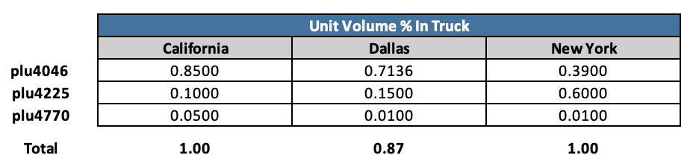
Avocado Units Per Truck to Each Market:
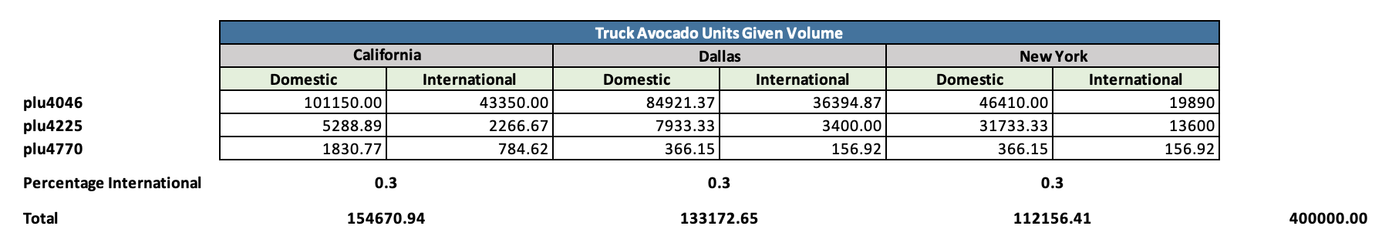
Shipping Costs:
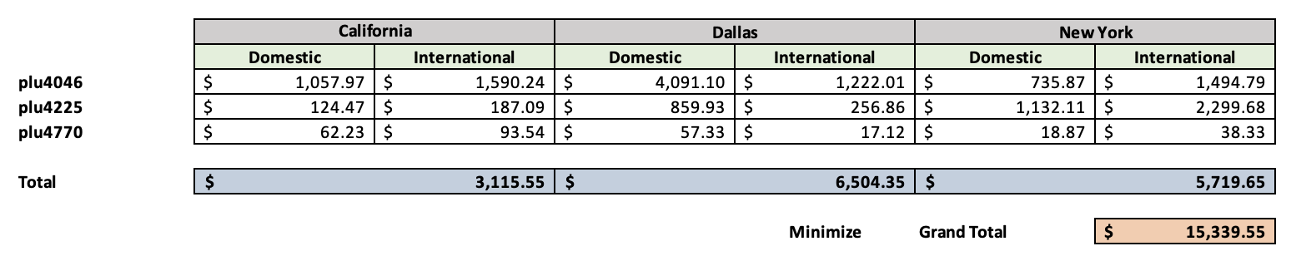
The optimization results highlight how the recommended allocation balances cost efficiency with realistic market conditions. To meet forecasted demand, Los Angeles and New York would each receive a full truck of avocados per day, while Dallas-Fort Worth would receive a truck filled to roughly 87 percent capacity. PLU4046, being the least expensive to ship, accounted for the largest share of total volume, while the historical constraints ensured that other avocado types were still allocated appropriately to reflect past consumption patterns in each market.
The model produced a minimized total shipping cost of $15,339.55 per day for all three markets, including both domestic and international shipments. Examining the distribution between domestic and international sources revealed meaningful differences across the markets. Dallas-Fort Worth, for example, had lower costs for international shipments compared with domestic shipments because Mexico is geographically closer than California. As a result, a larger share of Dallas’s avocado volume was sourced internationally within the 30 percent allocation, while still meeting daily demand. These results demonstrate how the model accounts for both cost efficiency and practical supply constraints, including truck capacity and market preferences.
While this optimization provides a strong foundation for cost-effective distribution, there are opportunities for refinement. Incorporating tariffs for international shipments would give a more complete view of the financial tradeoffs between domestic and imported avocados and could shift the balance toward domestic sourcing. Adjusting the constraints on international allocation could also further reduce costs, particularly for markets like Dallas-Forth Worth that benefit from lower international shipping expenses. Overall, the model demonstrates how data-driven decision making can guide supply allocation while respecting both market behavior and operational realities.
Findings and Recommendations
While our Autoregressive (AR) model produced reliable forecasts and captured the broad underlying trend in avocado demand, it did not explicitly model recurring seasonal patterns. Weekly avocado sales consistently rise and fall around predictable events like holidays, cultural celebrations, weather shifts, and annual consumption cycles. Because the AR model relies solely on past values without a dedicated seasonal structure, it tends to smooth out these regular spikes rather than learning their true magnitude.
A more effective approach for capturing these seasonal effects would be to incorporate regression with seasonal dummy variables. Since the dataset already includes features such as Month, Year, and Week, these can be transformed into indicator variables that represent specific seasonal periods. This allows the model to directly estimate how demand typically changes in each month or week, rather than assuming all historical periods influence the future equally. With this structure, the model can learn that demand tends to rise before events like the Super Bowl or Cinco de Mayo, or that certain months consistently show lower sales volumes.
Unlike a pure AR model, which treats all past weeks uniformly, seasonal dummy regression allows the model to learn the precise size and direction of seasonal influences. This would improve accuracy during high variance times of year and reduce the likelihood of missing predictable seasonal spikes. Incorporating seasonal dummy variables in future iterations of the forecasting model would therefore offer a clearer representation of recurring seasonal patterns, lower forecast error around major demand events, and provide avocado suppliers with more precise insights for planning inventory, logistics, and promotional strategy.
A similar refinement is also recommended for the prescriptive optimization component. In our model, shipment quantities were restricted to align closely with historical average volumes for each city. While this ensured consistency with past behavior, it also introduced a significant limitation: we do not fully understand the factors that drove those historical volumes. Past allocations may reflect supply shortages, inefficient distribution routes, outdated supplier contracts, weather-related disruptions, or operational constraints that are no longer relevant. By forcing the optimization to follow these patterns, the model is prevented from identifying the true cost-optimal shipping strategy.
To address this, future optimization efforts should consider relaxing or removing the historical volume constraints. Instead, the model should be allowed to allocate shipments guided only by realistic business considerations such as supplier capacity, minimum reliability standards, spoilage rates, and forecasted demand. Integrating the improved predictive forecast, rather than historical averages as the demand input, would ensure that the optimization reflects expected future conditions rather than legacy behaviors.
Together, these enhancements to both the predictive and prescriptive models would create a more accurate and flexible decision-making framework for avocado distribution. By explicitly modeling seasonality and removing unnecessary historical constraints, the entire system becomes more forward-looking and better aligned with real market dynamics. Implementing these improvements would not only strengthen forecast reliability but also reveal more cost-efficient supply strategies, ultimately supporting smarter planning, reduced waste, and more resilient operations across all regions.
References
Vakharia, P. (2025). Avocado prices and sales volume 2015–2023 [Data set]. Kaggle.
https://www.kaggle.com/datasets/vakhariapujan/avocado-prices-and-sales-volume-2015-2023/data
U.S. Department of Agriculture, Agricultural Marketing Service. (2025, January). Agricultural
Refrigerated Truck Quarterly: Quarter 2, April–June 2024.
https://www.ams.usda.gov/sites/default/files/media/RTQ2ndQuarter2024.pdf
U.S. Department of Agriculture, Agricultural Marketing Service. (2025). Advertised prices for specialty
crops products at major retail supermarket outlets: Ending during the period of 11/22/2025 to
12/4/2025 [PDF]. https://www.ams.usda.gov/mnreports/fvwretail.pdf

